UNIVERSITY OF GHANA
DEPARTMENT OF STATISTICS AND ACTUARIAL SCIENCES
ASTA 607
ID: 22424325

Question1
a.CODES
# (a) describe
?crabs

OUTPUT
The crabs data frame has 200 rows and 8 columns, describing 5 morphological measurements on 50 crabs each of two colour forms and both sexes, of the species Leptograpsus variegatus collected at Fremantle, W. Australia.

b.CODES

data(crabs)
str(crabs)
head(crabs)

OUTPUT
> data(crabs)
> str(crabs)
'data.frame': 200 obs. of 8 variables:
$ sp : Factor w/ 2 levels "B","O": 1 1 1 1 1 1 1 1 1 1 ...
$ sex : Factor w/ 2 levels "F","M": 2 2 2 2 2 2 2 2 2 2 ...
$ index: int 1 2 3 4 5 6 7 8 9 10 ...
$ FL : num 8.1 8.8 9.2 9.6 9.8 10.8 11.1 11.6 11.8 11.8 ...
$ RW : num 6.7 7.7 7.8 7.9 8 9 9.9 9.1 9.6 10.5 ...
$ CL : num 16.1 18.1 19 20.1 20.3 23 23.8 24.5 24.2 25.2 ...
$ CW : num 19 20.8 22.4 23.1 23 26.5 27.1 28.4 27.8 29.3 ...
$ BD : num 7 7.4 7.7 8.2 8.2 9.8 9.8 10.4 9.7 10.3 ...
> head(crabs)
sp sex index FL RW CL CW BD
1 B M 1 8.1 6.7 16.1 19.0 7.0
2 B M 2 8.8 7.7 18.1 20.8 7.4
3 B M 3 9.2 7.8 19.0 22.4 7.7
4 B M 4 9.6 7.9 20.1 23.1 8.2
5 B M 5 9.8 8.0 20.3 23.0 8.2
6 B M 6 10.8 9.0 23.0 26.5 9.8

c.CODES

sfreq <- table(crabs$sp, crabs$sex)
rownames(sfreq) <- rbind("Blue", "Orange")
print(sfreq)

OUTPUT
# (c) produce frequency tables for species and sex
> table(crabs$sp)

B O
100 100
> table(crabs$sex)

F M
100 100
> tab_sp_sex <- table(Species = crabs$sp, Sex = crabs$sex)
> tab_sp_sex
Sex
Species F M
B 50 50
O 50 50
> prop.table(tab_sp_sex)
Sex
Species F M
B 0.25 0.25
O 0.25 0.25
> prop.table(tab_sp_sex, margin = 1)
Sex
Species F M
B 0.5 0.5
O 0.5 0.5
> prop.table(tab_sp_sex, margin = 2)
Sex
Species F M
B 0.5 0.5
O 0.5 0.5

d.CODES

barplot(sfreq, xlab = "Sex", ylab = "Frequency", main = "Composite barchart of species by sex",
col = c("blue", "orange"), legend = TRUE)

OUTPUT
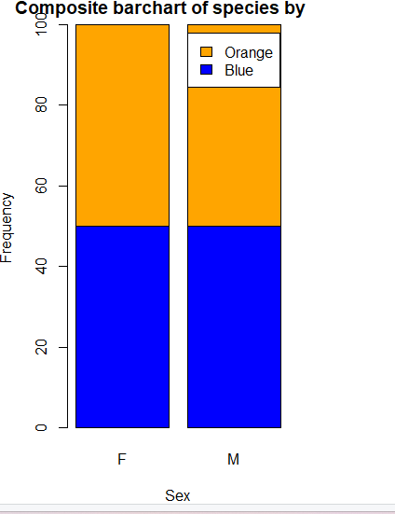

e.
(e) balance across four groups
group_counts <- as.vector(tab_sp_sex)
min(group_counts)
max(group_counts)
min(group_counts) == max(group_counts)

COMMENTS
From the barplot above, it can be seen that the dataset(crabs)is balanced across the four groups. This means that Anova can be used for further comparison amongst them and the results will be unbiased.

Question2

a.CODES
?boxplot
par(mfrow = c(1,1), mar = c(4,4,2,1))
boxplot(BD ~ sp * sex, data = crabs,col = c("blue", "orange"),
main = "Side-by-Side Boxplots of Body Depth",
xlab = "Species and Sex",
ylab = "Body Depth")

OUTPUT
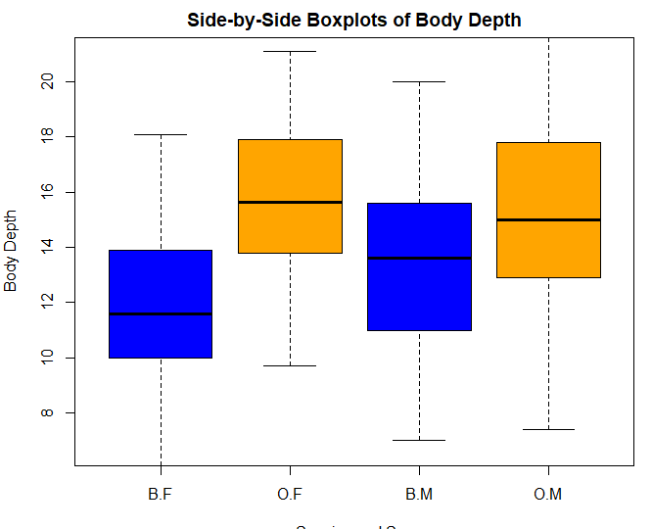

Descriptive statistics by group
group: B
vars n mean sd median trimmed mad min max range skew kurtosis
X1 1 100 12.58 3.07 12.6 12.55 3.26 6.1 20 13.9 0.07 -0.72
se
X1 0.31
------------------------------------------------------
group: O
vars n mean sd median trimmed mad min max range skew kurtosis
X1 1 100 15.48 3.15 15.55 15.51 3.41 7.4 21.6 14.2 -0.08 -0.6
se
X1 0.32
> describeBy(x=crabs$BD, group=crabs$sex)

Descriptive statistics by group
group: F
vars n mean sd median trimmed mad min max range skew kurtosis
X1 1 100 13.72 3.34 13.8 13.74 3.56 6.1 21.1 15 -0.02 -0.68
se
X1 0.33
------------------------------------------------------
group: M
vars n mean sd median trimmed mad min max range skew kurtosis
X1 1 100 14.34 3.49 14.2 14.31 4 7 21.6 14.6 0.03 -0.62
se
X1 0.35

>

COMMENTS

Question3
a.CODES
?hist
par(mfrow = c(1,2), mar = c(4,4,2,1))
hist(crabs$CL[crabs$sp == "B"], xlab = "Carapace Length (in mm)", main = "Blue", col = "blue")
hist(crabs$CL[crabs$sp == "O"], xlab = "Carapace Length (in mm)", main = "Orange", col = "orange")
#Describe
tapply(crabs$CL, crabs$sp, summary)

OUTPUT
$B
Min. 1st Qu. Median Mean 3rd Qu. Max.
14.70 24.85 30.10 30.06 34.60 47.10

$O
Min. 1st Qu. Median Mean 3rd Qu. Max.
16.70 29.20 34.55 34.15 39.40 47.60

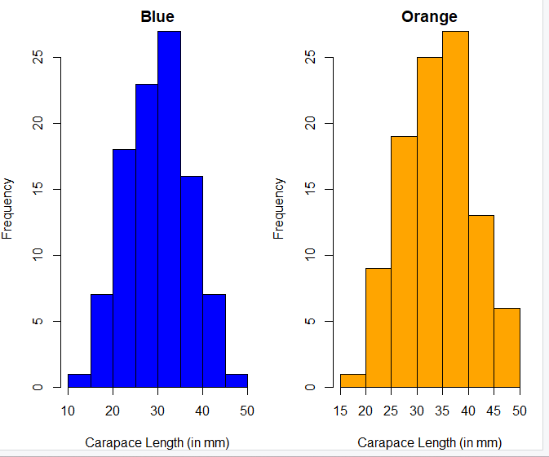

COMMENTS

Both histogram of carapace length by species and sex are normally skewed and have unimodality. That is the highest length are same

b.CODES
library(e1071)
tapply(crabs$CL,crabs$sp,skewness)
tapply(crabs$CL,crabs$sex,mode)

OUTPUT

COMMENTS

Question4

a.CODES
##Q4##
##a###
tapply(crabs$FL,crabs$sp,mean)
tapply(crabs$RW,crabs$sp,mean)
tapply(crabs$CL,crabs$sp,mean)
tapply(crabs$CW,crabs$sp,mean)
tapply(crabs$BD,crabs$sp,mean)

tapply(crabs$FL,crabs$sex,mean)
tapply(crabs$RW,crabs$sex,mean)
tapply(crabs$CL,crabs$sex,mean)
tapply(crabs$CW,crabs$sex,mean)
tapply(crabs$BD,crabs$sex,mean)

##b##
par(mfrow=c(1,5))
barplot(tapply(crabs$FL,crabs$sp,mean), names.arg = c("B","O"), col = "blue", xlab =
"Species", ylab = "Mean Values",
main = "Mean Values of FL for Species")
barplot(tapply(crabs$RW,crabs$sp,mean), names.arg = c("B","O"), col = "pink", xlab =
"Species", ylab = "Mean Values",
main = "Mean Values of RW for Species")
barplot(tapply(crabs$CL,crabs$sp,mean), names.arg = c("B","O"), col = "green", xlab =
"Species", ylab = "Mean Values",
main = "Mean Values of CL for Species")
barplot(tapply(crabs$CW,crabs$sp,mean), names.arg = c("B","O"), col = "red", xlab =
"Species", ylab = "Mean Values",
main = "Mean Values of CW for Species")
barplot(tapply(crabs$BD,crabs$sp,mean), names.arg = c("B","O"), col = "gold", xlab =
"Species", ylab = "Mean Values",
main = "Mean Values of BD for Species")

)
## for each measurement
par(mfrow=c(1,4))
barplot(barchart$mean_B, names.arg = barchart$variables, col = "blue", xlab =
"Measurements", ylab = "Mean Values",
main = "Mean Values of Measurements for Species B")
barplot(barchart$mean_O, names.arg = barchart$variables, col = "orange", xlab =
"Measurements", ylab = "Mean Values",
main = "Mean Values of Measurements for Species O")
barplot(barchart$mean_M, names.arg = barchart$variables, col = "green", xlab =
"Measurements", ylab = "Mean Values",
main = "Mean Values of Measurements for Males")
barplot(barchart$mean_F, names.arg = barchart$variables, col = "pink", xlab =
"Measurements", ylab = "Mean Values",main=
"Mean Values of Measurements for Females")

OUTPUT
> tapply(crabs$FL,crabs$sp,mean)
B O
14.056 17.110
> tapply(crabs$RW,crabs$sp,mean)
B O
11.928 13.549
> tapply(crabs$CL,crabs$sp,mean)
B O
30.058 34.153
> tapply(crabs$CW,crabs$sp,mean)
B O
34.717 38.112
> tapply(crabs$BD,crabs$sp,mean)
B O
12.583 15.478
> tapply(crabs$FL,crabs$sex,mean)
F M
15.432 15.734
> tapply(crabs$RW,crabs$sex,mean)
F M
13.487 11.990
> tapply(crabs$CL,crabs$sex,mean)
F M
31.360 32.851
> tapply(crabs$CW,crabs$sex,mean)
F M
35.830 36.999
> tapply(crabs$BD,crabs$sex,mean)
F M
13.724 14.337
> ##Q4##
> ##a###
> tapply(crabs$FL,crabs$sp,mean)
B O
14.056 17.110
> tapply(crabs$RW,crabs$sp,mean)
B O
11.928 13.549
> tapply(crabs$CL,crabs$sp,mean)
B O
30.058 34.153
> tapply(crabs$CW,crabs$sp,mean)
B O
34.717 38.112
> tapply(crabs$BD,crabs$sp,mean)
B O
12.583 15.478
> tapply(crabs$FL,crabs$sex,mean)
F M
15.432 15.734
> tapply(crabs$RW,crabs$sex,mean)
F M
13.487 11.990
> tapply(crabs$CL,crabs$sex,mean)
F M
31.360 32.851
> tapply(crabs$CW,crabs$sex,mean)
F M
35.830 36.999
> tapply(crabs$BD,crabs$sex,mean)
F M
13.724 14.337

b.CODES
par(mfrow=c(1,5))
barplot(tapply(crabs$FL,crabs$sp,mean), names.arg = c("B","O"), col = "blue", xlab =
"Species", ylab = "Mean Values",
main = "Mean Values of FL for Species")
barplot(tapply(crabs$RW,crabs$sp,mean), names.arg = c("B","O"), col = "pink", xlab =
"Species", ylab = "Mean Values",
main = "Mean Values of RW for Species")
barplot(tapply(crabs$CL,crabs$sp,mean), names.arg = c("B","O"), col = "green", xlab =
"Species", ylab = "Mean Values",
main = "Mean Values of CL for Species")
barplot(tapply(crabs$CW,crabs$sp,mean), names.arg = c("B","O"), col = "red", xlab =
"Species", ylab = "Mean Values",
main = "Mean Values of CW for Species")
barplot(tapply(crabs$BD,crabs$sp,mean), names.arg = c("B","O"), col = "gold", xlab =
"Species", ylab = "Mean Values",
main = "Mean Values of BD for Species")4 BD 10.52 9.97 10.24 10.24

OUTPUT

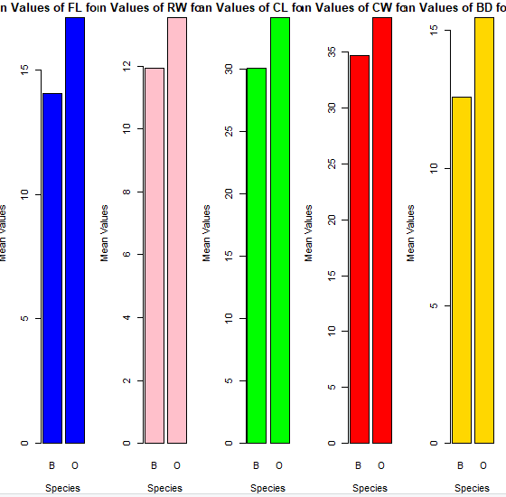

COMMENTS

Question5

CODES
##Q5
# Produce a scatterplot matrix (pairs plot) of the five mearsurement
# Select the five measurements
fivemeasures <- crabs[, c("FL", "RW", "CL", "CW", "BD")]

#Scatter plot for the 5
pairs(fivemeasures,
main = "Scatterplot Matrix(pairs plot) of the 5 Crab Measurements",
pch = 19,
col = "red")

OUTPUT
